**EVALUATING ACCURACY OF THE CLASSIFIERS**

**AIM:**

To evaluate accuracy of the classifiers using weka.

**DESCRIPTION :**

Consider the german credit dataset which can be downloaded from the UCI repository.

1. **Logistic Regression :**

Logistic regression predicts the probability of an outcome that can only have two values (i.e. a dichotomy). The prediction is based on the use of one or several predictors (numerical and categorical)

Load the dataset into the weka tool and preprocess it.

Apply the classification the logistic regression technique and execute for the result.

**Output :**

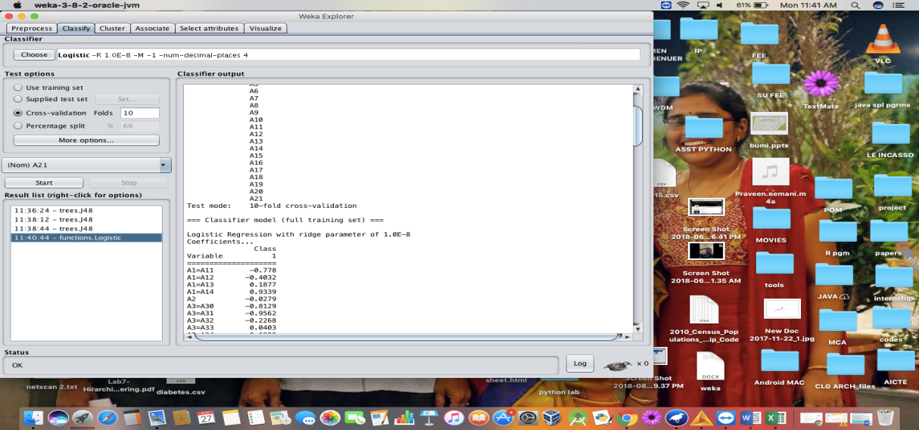

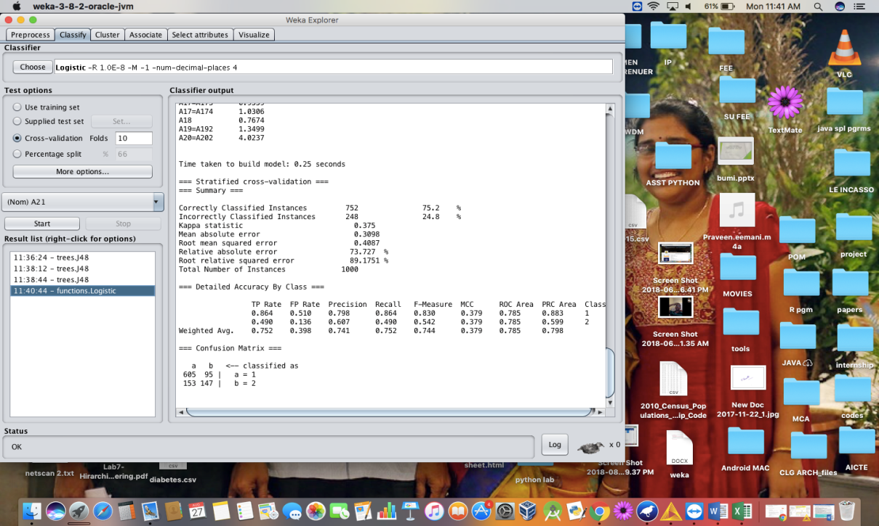

1. **Naïve Bayes Algorithm :**

The Naive Bayesian classifier is based on Bayes’ theorem with the independence assumptions between predictors. A Naive Bayesian model is easy to build, with no complicated iterative parameter estimation which makes it particularly useful for very large datasets. Despite its simplicity, the Naive Bayesian classifier often does surprisingly well and is widely used because it often outperforms more sophisticated classification methods.

Load the dataset into the weka tool and preprocess it.

Apply the classification the Naïve bayes technique and execute for the result.

**Output :**

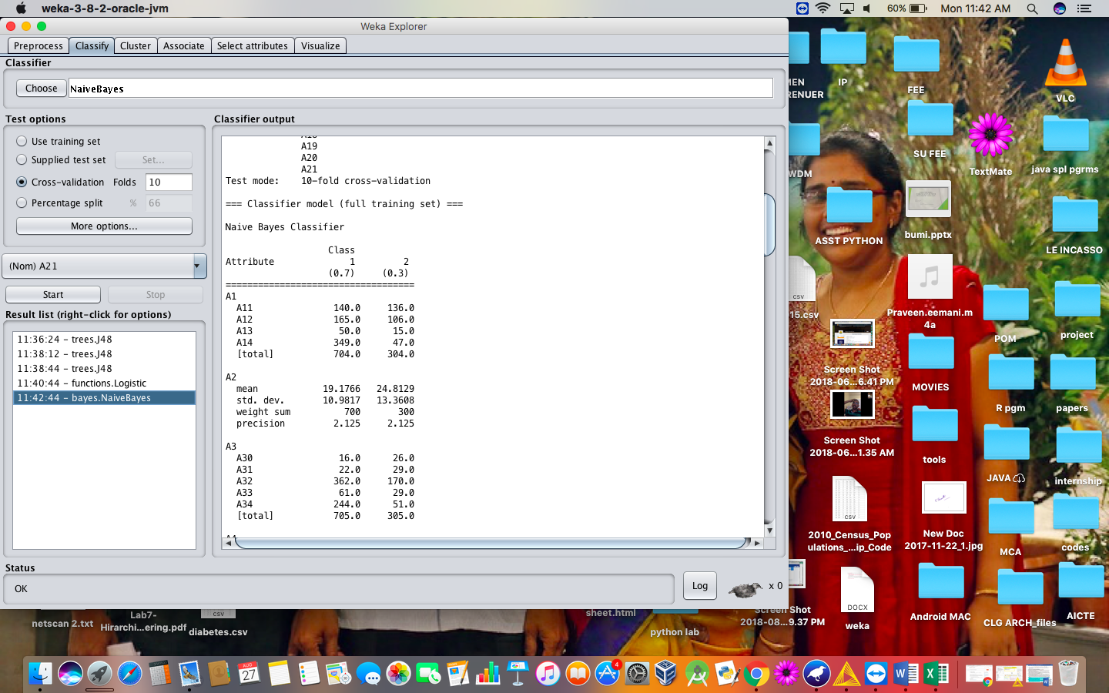

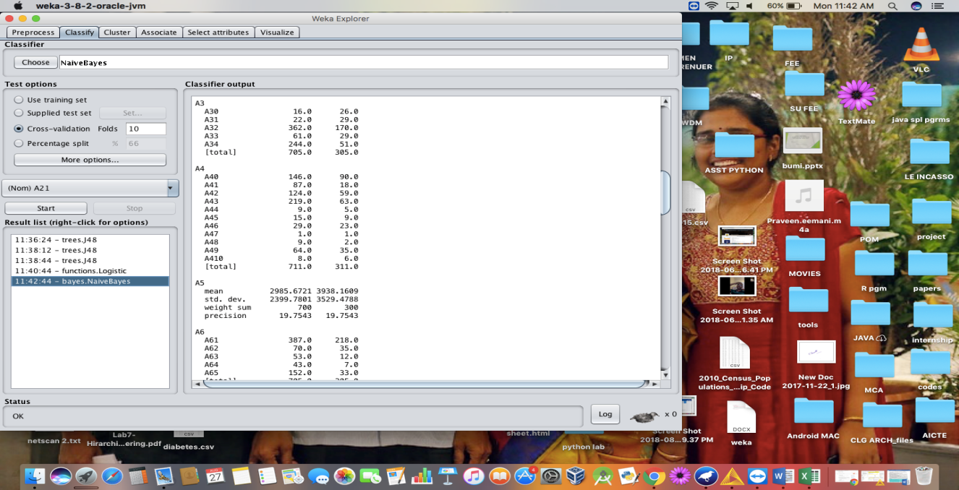

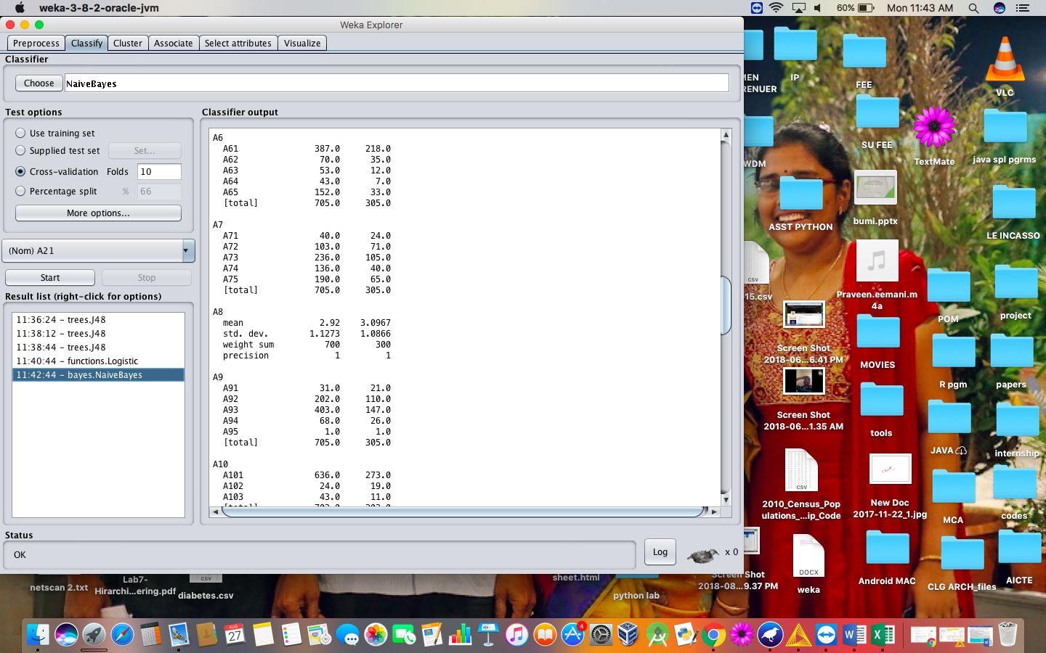

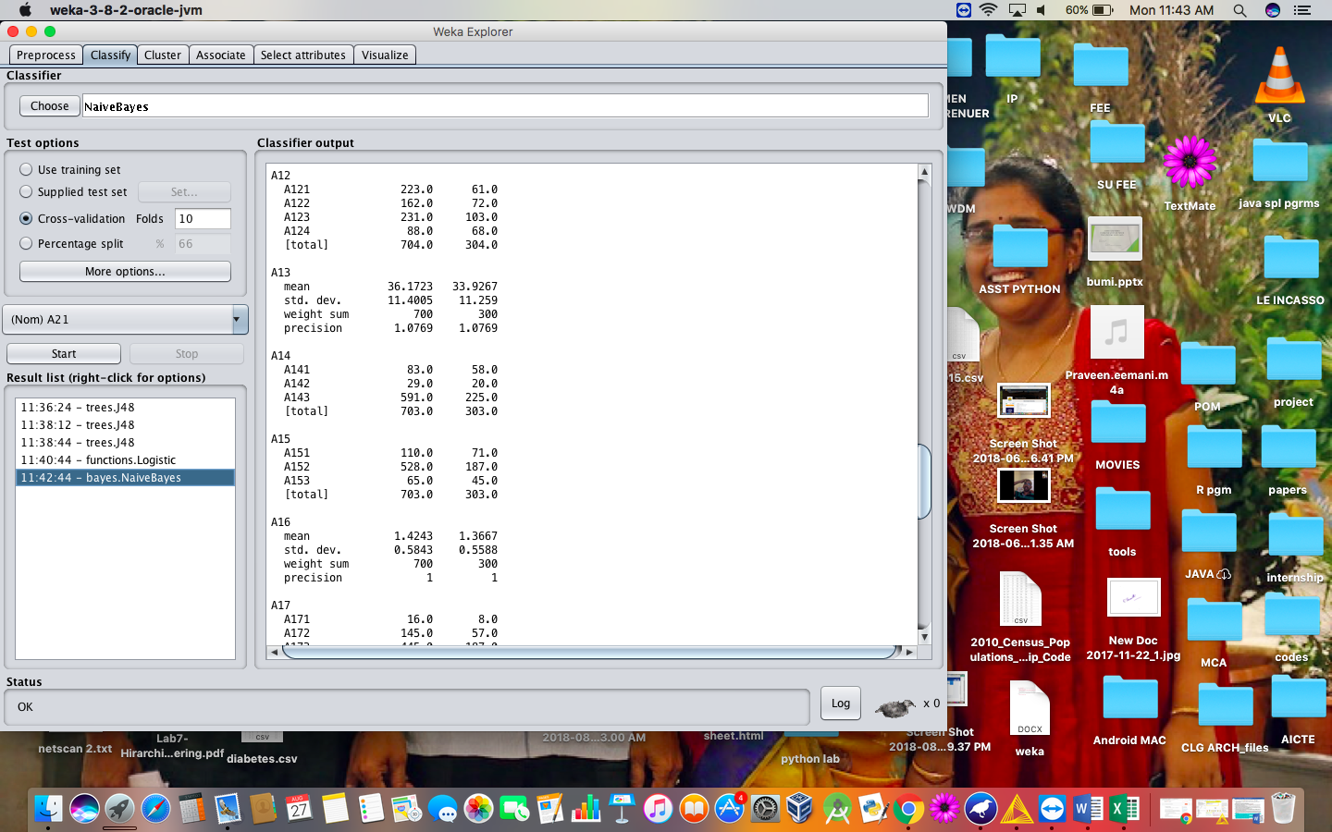

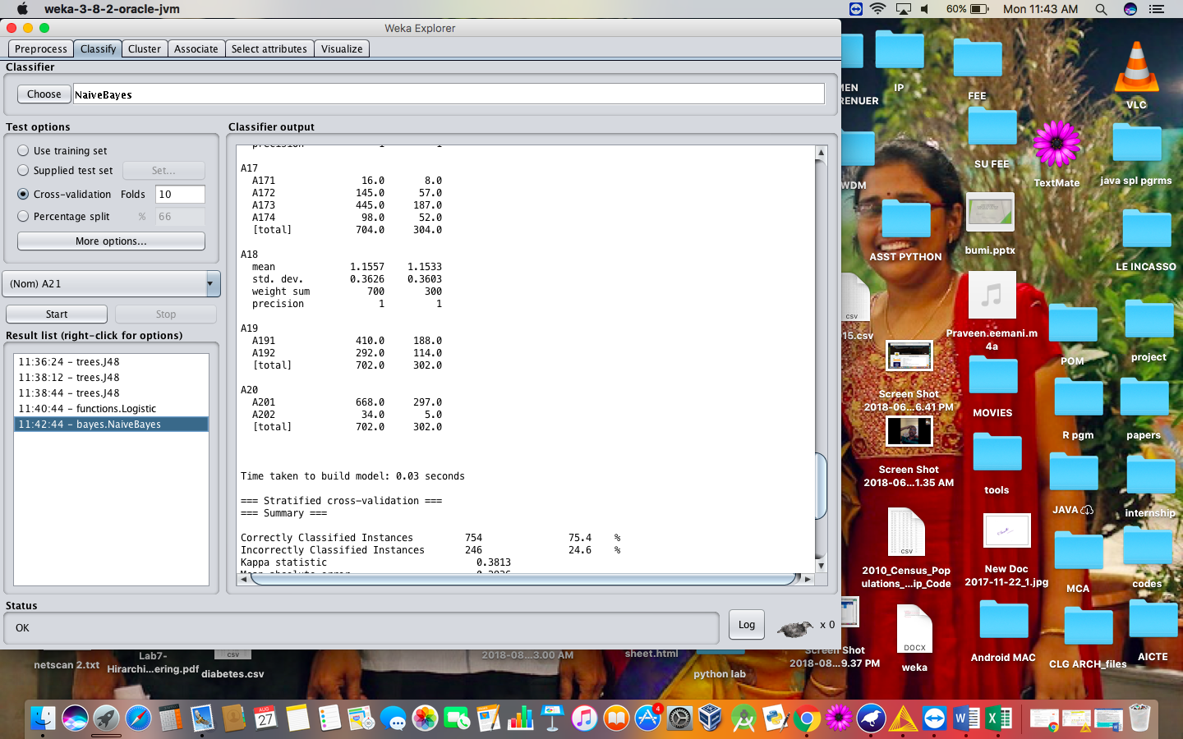

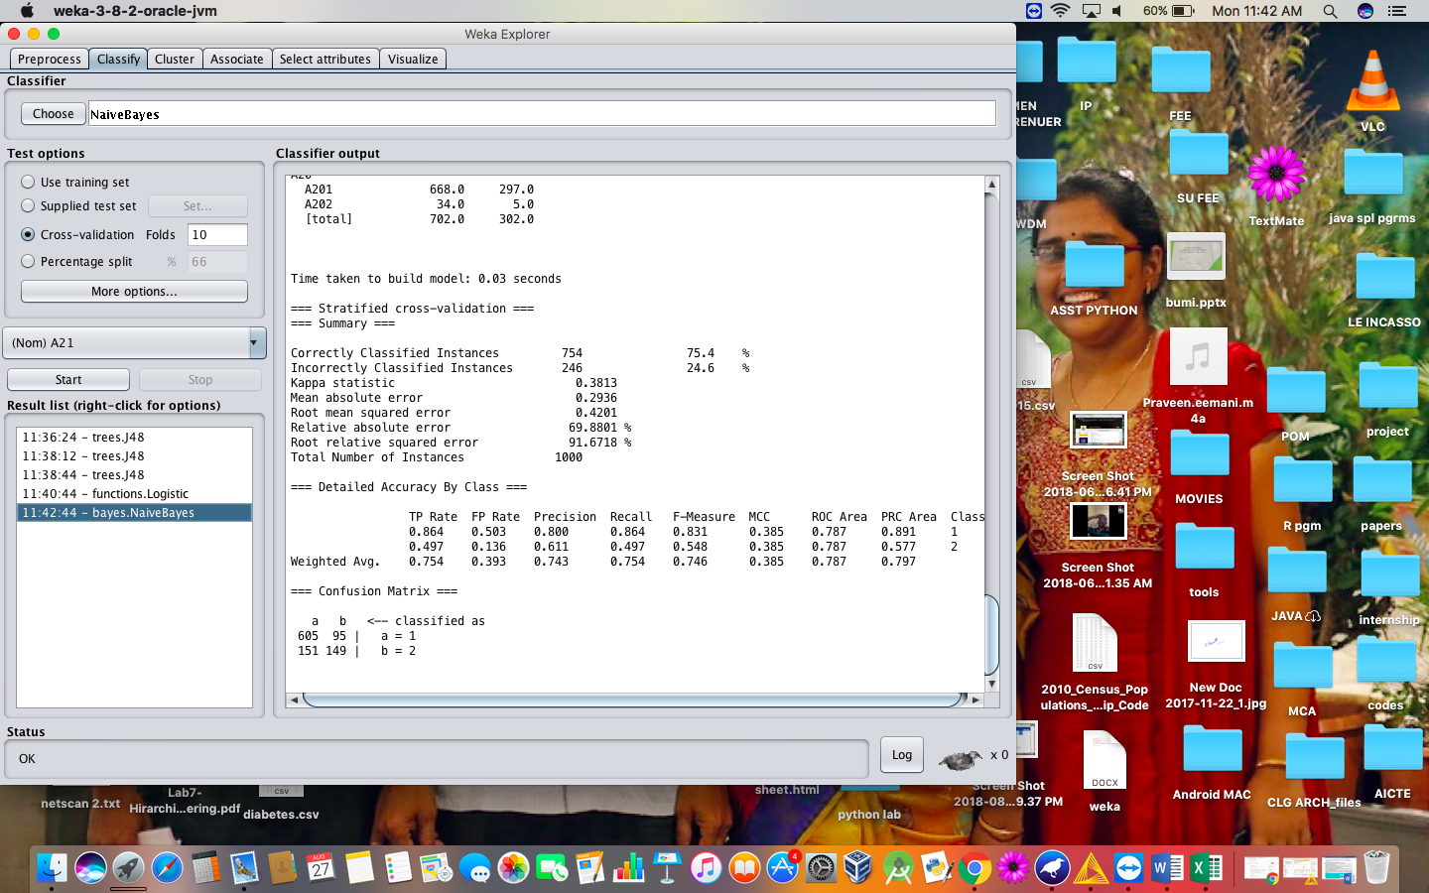

1. **J48 Algorithm :**

Classification is the process of building a model of classes from a set of records that contain class labels. Decision Tree Algorithm is to find out the way the attributes-vector behaves for a number of instances. Also on the bases of the training instances the classes for the newly generated instances are being found. This algorithm generates the rules for the prediction of the target variable. With the help of tree classification algorithm the critical distribution of the data is easily understandable.

Load the dataset into the weka tool and preprocess it.

Apply the classification the J48 technique and execute for the result.

**Output :**

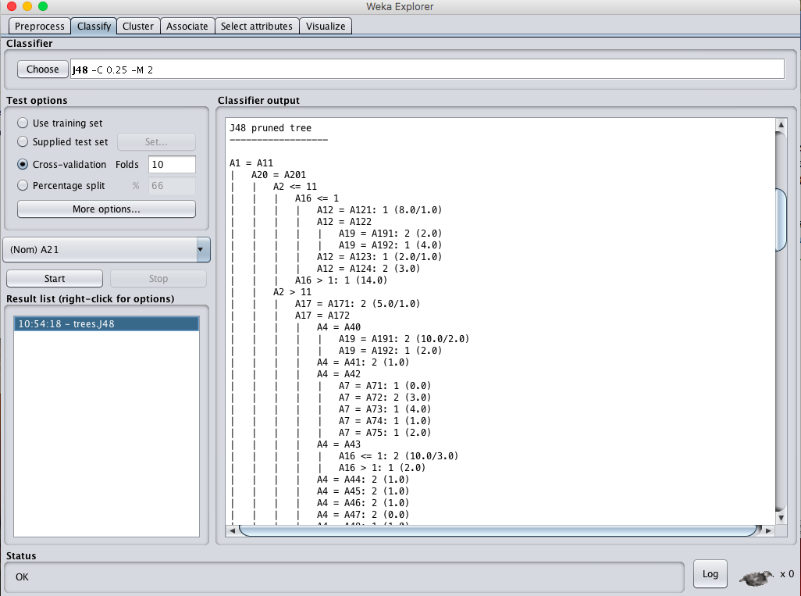

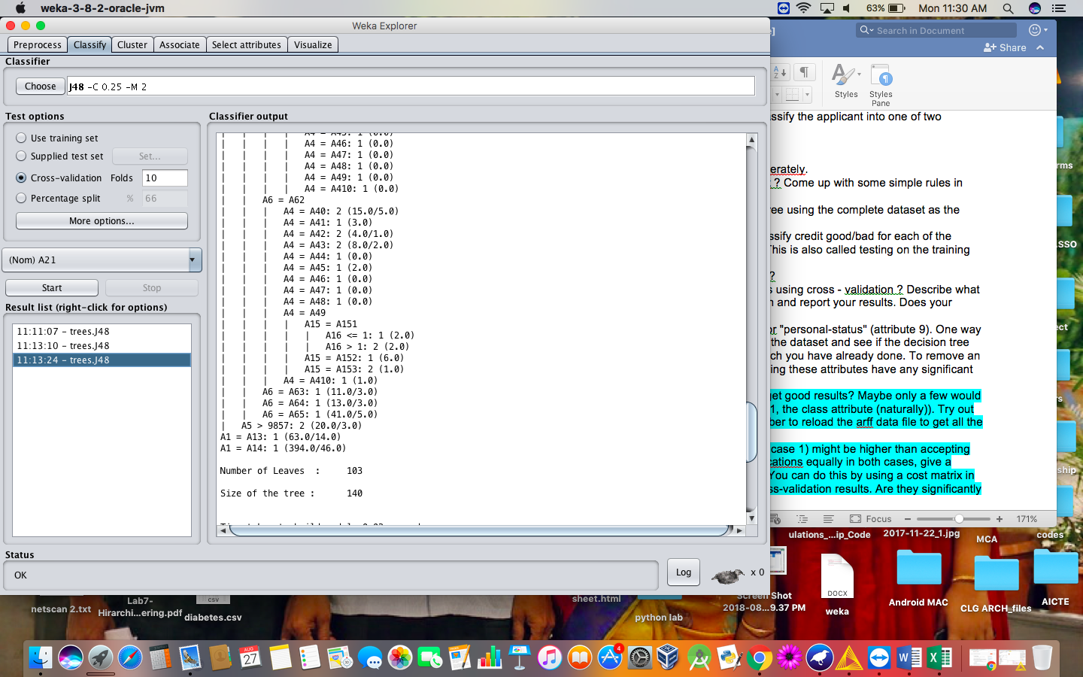

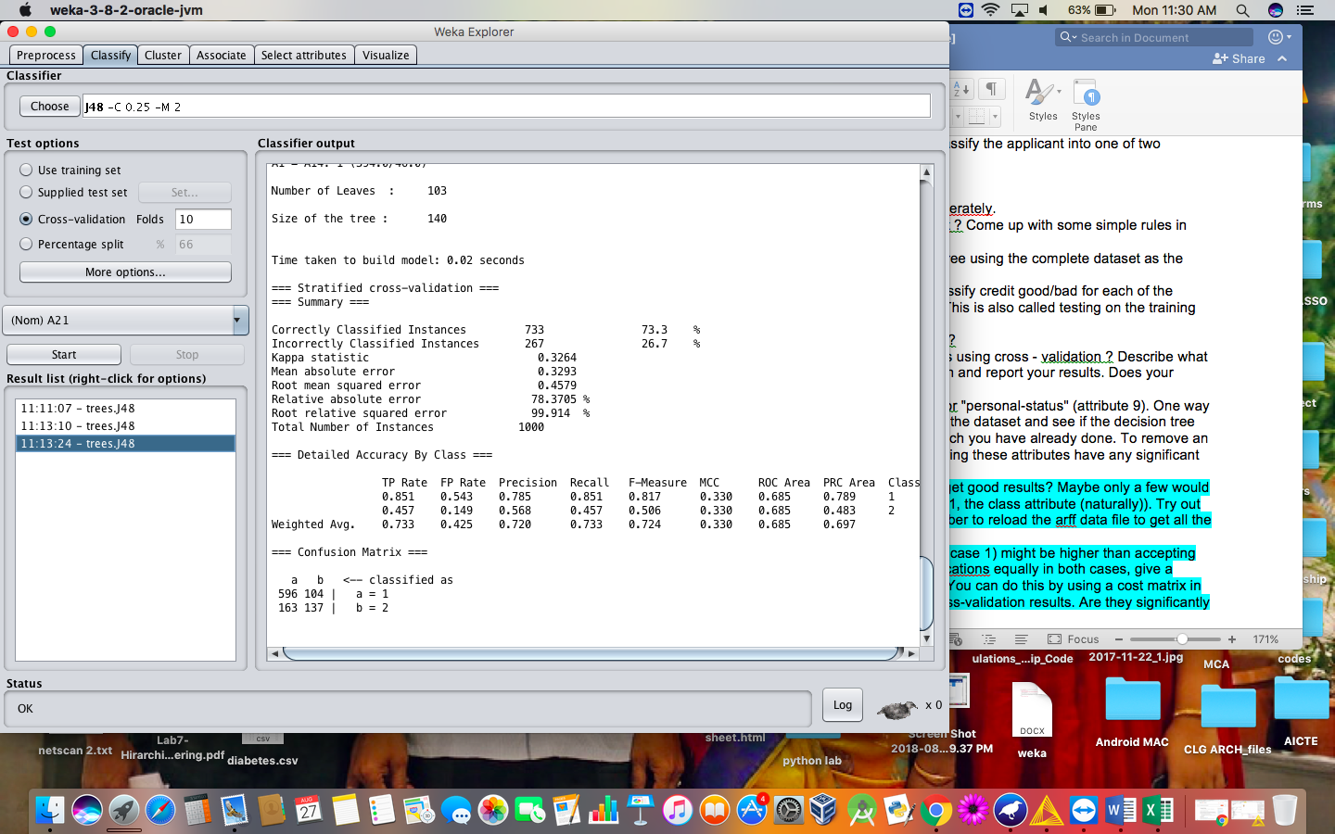

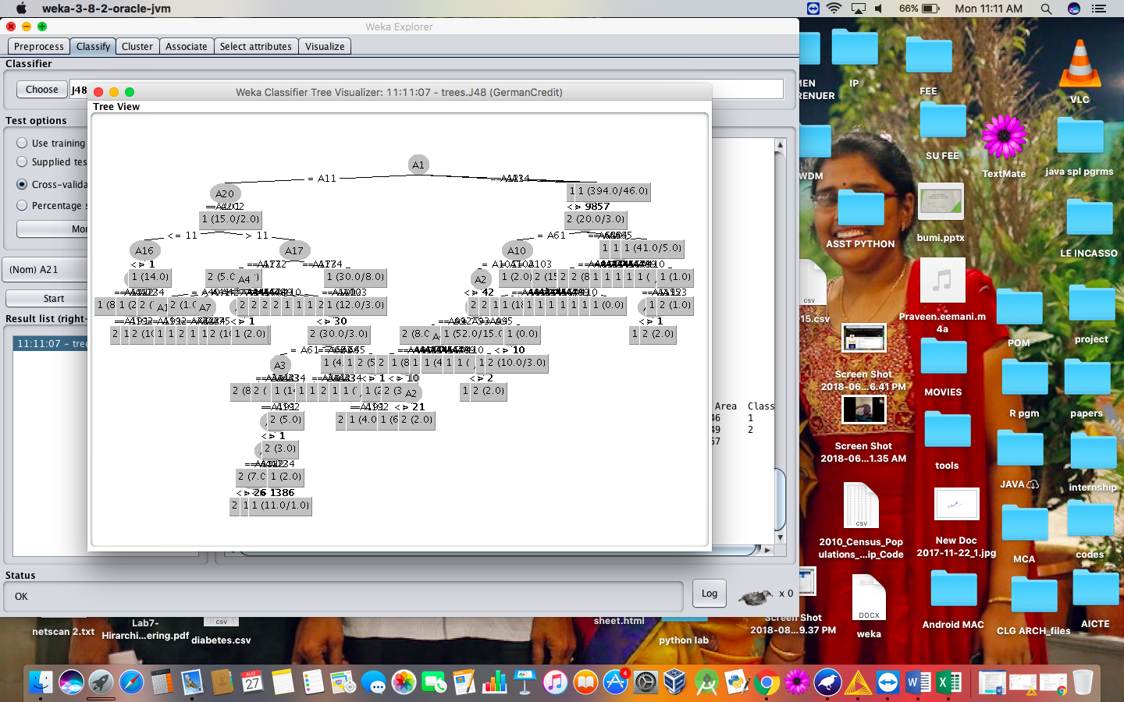

1. **K-Nearest Neighbor :**

K-Nearest Neighbors is one of the most basic yet essential classification algorithms in Machine Learning. It belongs to the supervised learning domain and finds intense application in pattern recognition, data mining and intrusion detection.

It is widely disposable in real-life scenarios since it is non-parametric, meaning, it does not make any underlying assumptions about the distribution of data (as opposed to other algorithms such as GMM, which assume a Gaussian distribution of the given data).

We are given some prior data (also called training data), which classifies coordinates into groups identified by an attribute.

Load the dataset into the weka tool and preprocess it.

Apply the classification the K- Nearest Neighbor technique and execute for the result.

**Output :**

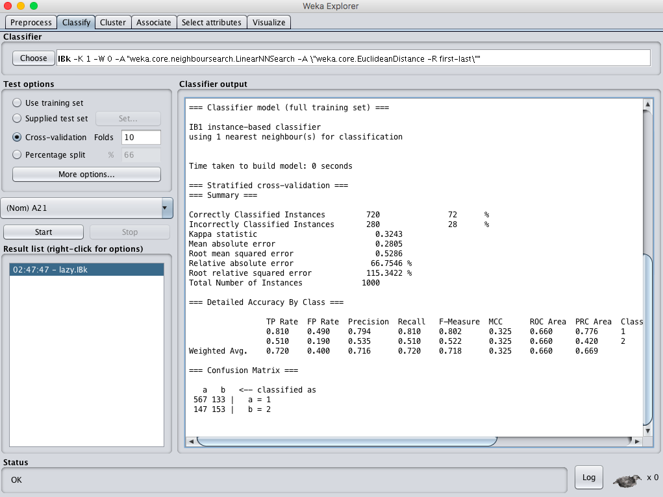

1. **SMO Algorithm :**

The iterative algorithm Sequential Minimal Optimization (SMO) is used for solving quadratic programming (QP) problems. One example where QP problems are relevant is during the training process of support vector machines (SVM). The SMO algorithm is used to solve in this example a constraint optimization problem. John Platt proposed this algorithm in 1998 and it was successfully used since then. We describe here the basics of the algorithm in the light of big data.

Load the dataset into the weka tool and preprocess it.

Apply the classification the Sequential Minimal Optimization (SMO)technique and execute for the result.

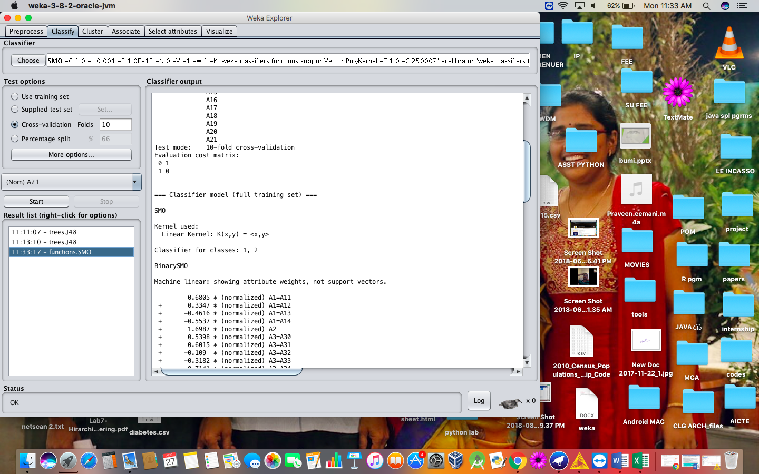

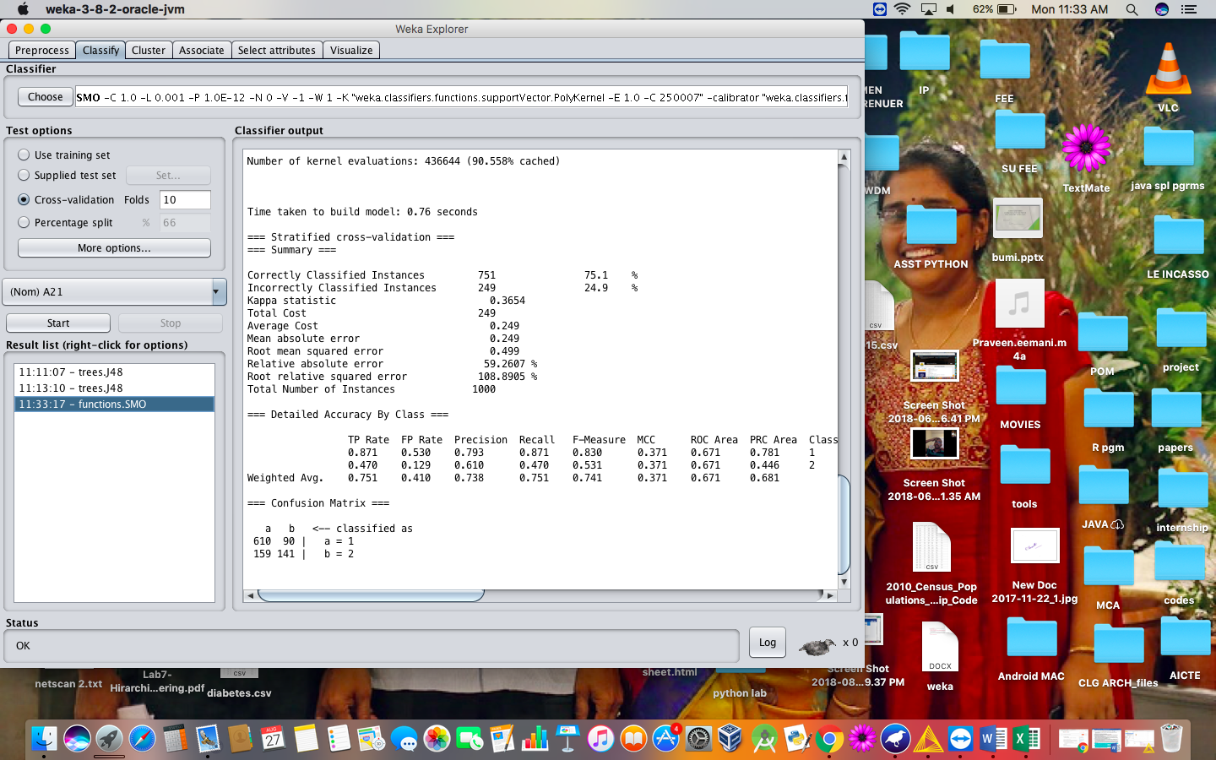

**RESULT :**

Thus, the comparison of the confusion matrix for all the methods and techniques. Out of the comparing matrix with all the techniques there is a change in instances. Naïve bayes has more number of correct instances than other but when compared to time K-nearest neighbor is best. The above graphs will show the variations of values in the parameters.